Лабораторна робота № 1

1. Приклади
   1. 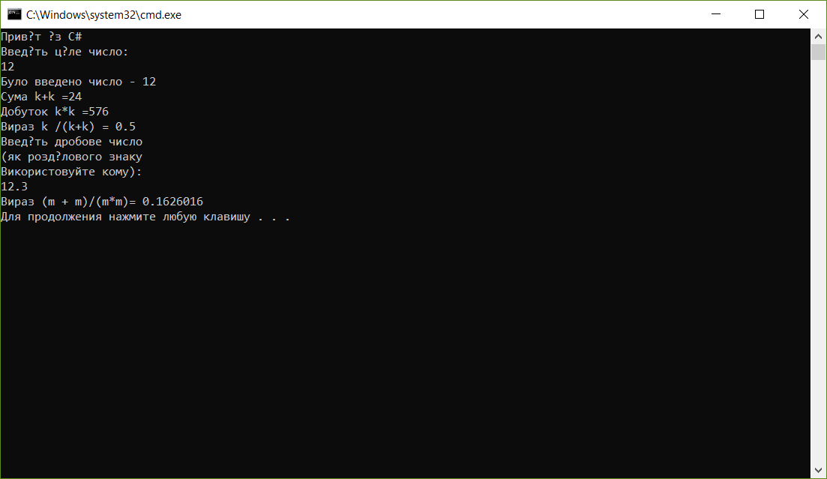Приклад 1
   2. 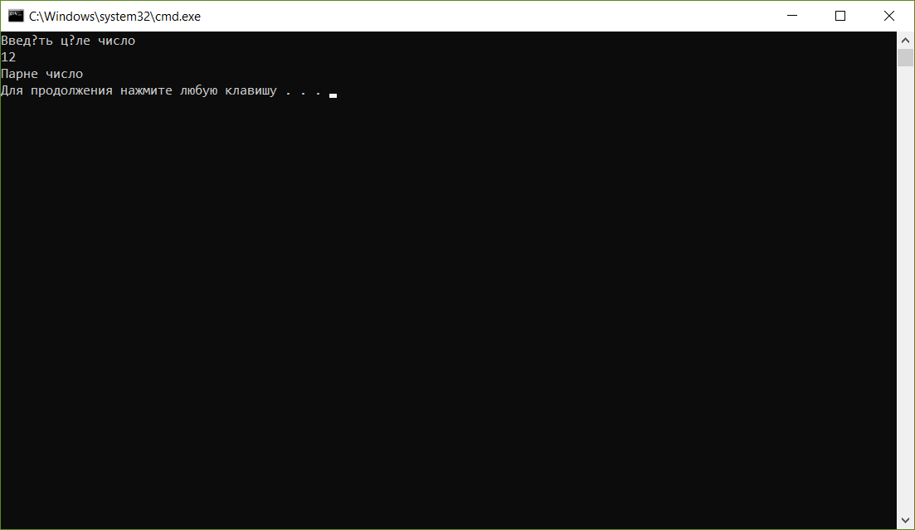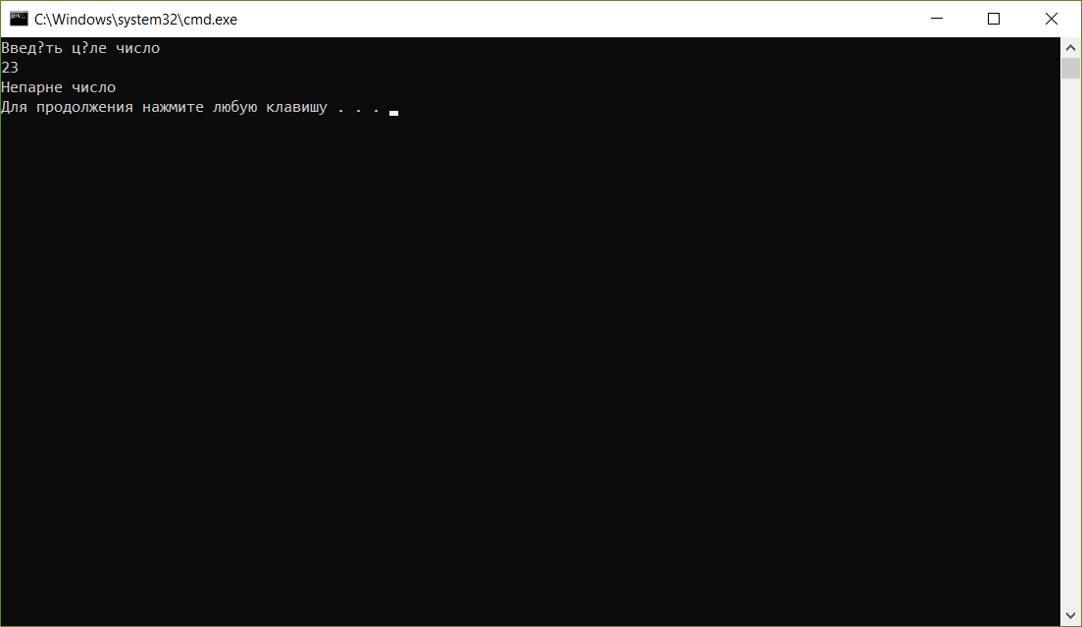Приклад 2
   3. Приклад 3  
      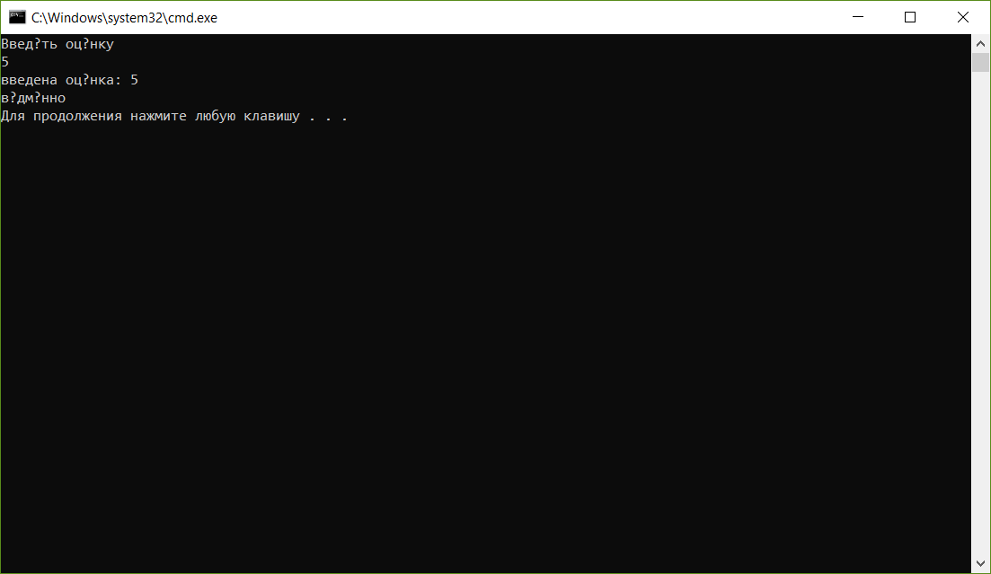
   4. Приклад 4

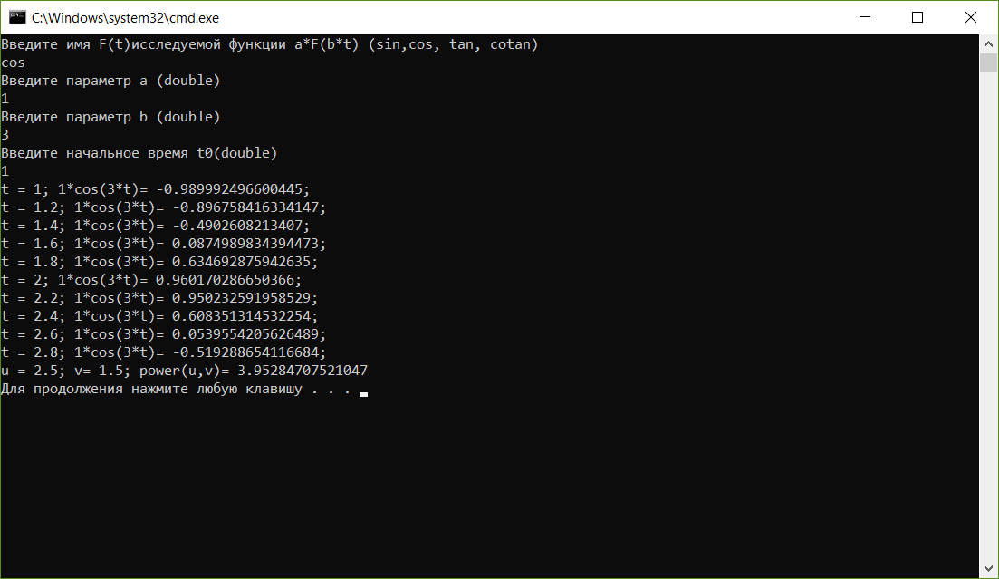

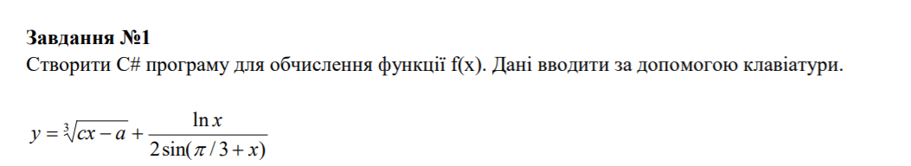

using System;

using System.Collections.Generic;

using System.Linq;

using System.Text;

using System.Threading.Tasks;

namespace ConsoleApp1

{

class Program

{

static void Main(string[] args)

{

double y;

Console.WriteLine("Enter c:");

double c = double.Parse(Console.ReadLine());

Console.WriteLine("Enter a:");

double a = double.Parse(Console.ReadLine());

Console.WriteLine("Enter x:");

double x = double.Parse(Console.ReadLine());

if (x > 0 && 2 \* Math.Sin(Math.PI / 3 + x) != 0)

{

y = Math.Pow((c \* x - a), (1.0 / 3)) + (Math.Log(x)) / (2 \* Math.Sin((Math.PI) / 3 + x));

Console.WriteLine("y=" + y);

}

else

{

Console.Write("Impossible to count");

}

}

}

}

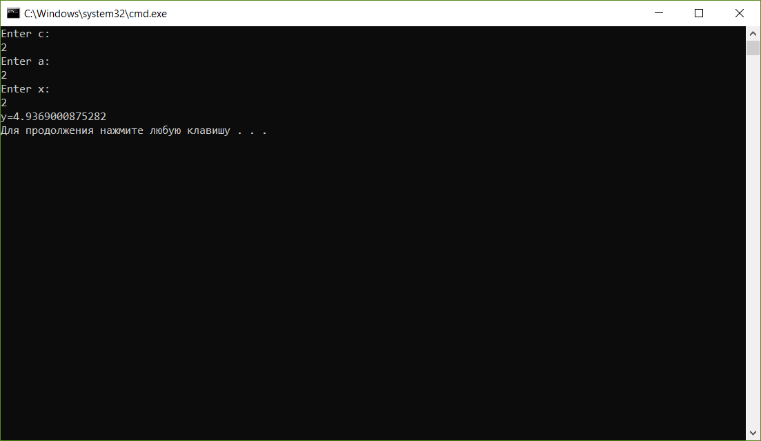

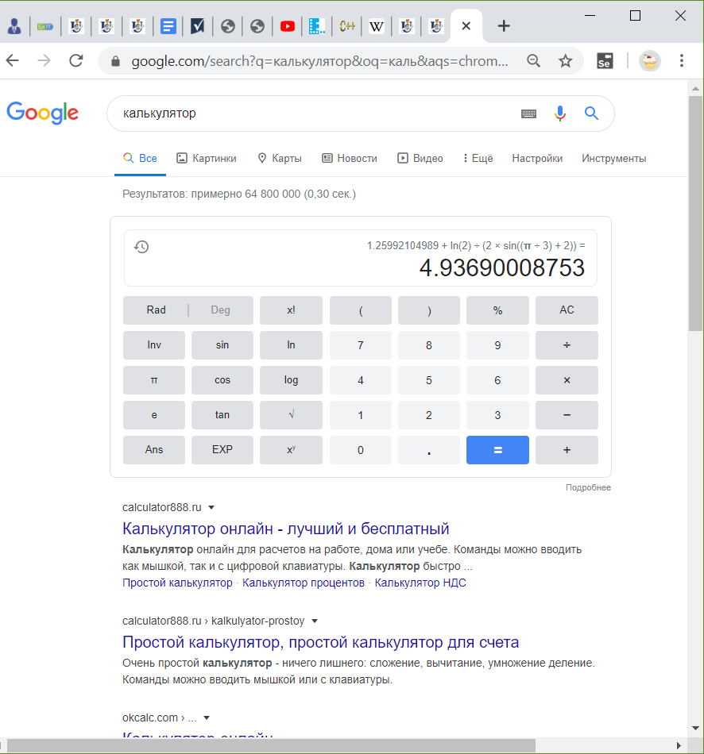

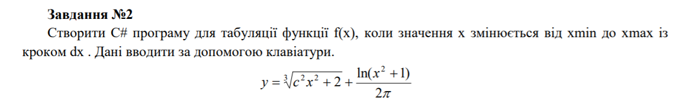

using System;

using System.Collections.Generic;

using System.Linq;

using System.Text;

using System.Threading.Tasks;

namespace ConsoleApp1

{

class Program

{

private static double pow(double a, double b)

{

if (a > 0)

return Math.Pow(a, b);

else

return -Math.Pow(-a, b);

}

static void Main(string[] args)

{

double y;

Console.WriteLine("Enter c:");

double c = double.Parse(Console.ReadLine());

Console.WriteLine("Enter xmin:");

double xmin = double.Parse(Console.ReadLine());

Console.WriteLine("Enter xmax:");

double xmax = double.Parse(Console.ReadLine());

Console.WriteLine("Enter dx:");

double dx = double.Parse(Console.ReadLine());

for (double x = xmin; x <= xmax; x += dx)

{

if ((Math.PI \* x)>0)

{

y = Math.Pow(c \* c \* x \* x + 2, (double)1 / 3) + Math.Log(x \* Math.PI)/(2\*Math.PI);

Console.WriteLine(" for x = " + x + " y=" + y);

}

else

{

Console.Write("Impossible to count\n");

}

}

}

}

}

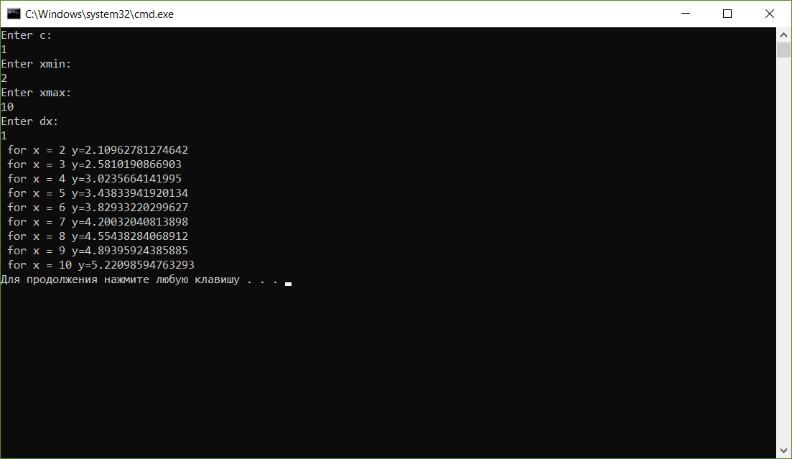

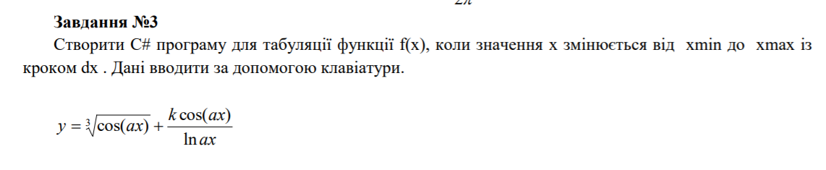

using System;

using System.Collections.Generic;

using System.Linq;

using System.Text;

using System.Threading.Tasks;

namespace ConsoleApp1

{

class Program

{

private static double pow(double a, double b)

{

if (a > 0)

return Math.Pow(a, b);

else

return -Math.Pow(-a, b);

}

static void Main(string[] args)

{

double y;

Console.WriteLine("Enter c:");

double c = double.Parse(Console.ReadLine());

Console.WriteLine("Enter a:");

double a = double.Parse(Console.ReadLine());

Console.WriteLine("Enter k:");

double k = double.Parse(Console.ReadLine());

Console.WriteLine("Enter xmin:");

double xmin = double.Parse(Console.ReadLine());

Console.WriteLine("Enter xmax:");

double xmax = double.Parse(Console.ReadLine());

Console.WriteLine("Enter dx:");

double dx = double.Parse(Console.ReadLine());

for (double x = xmin; x <= xmax; x += dx)

{

if (Math.Log(a\*x)!=0 && (a\*x)>0)

{

y = pow((Math.Cos(a\*x)), 1.0/3)+ (k\*Math.Cos(a\*x))/Math.Log(a\*x);

Console.WriteLine(" for x = " + x+ " y=" +y);

}

else

{

Console.Write("Impossible to count\n");

}

}

}

}

}

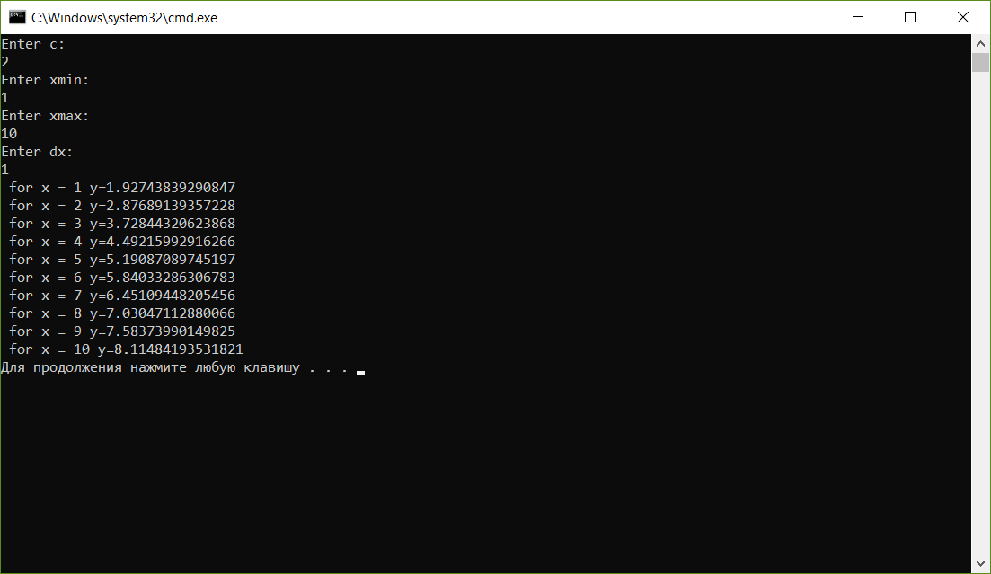



using System;

using System.Collections.Generic;

using System.Linq;

using System.Text;

using System.Threading.Tasks;

namespace ConsoleApp1

{

class Program

{

private static double Pow()

{

Console.WriteLine("Enter a:");

double a = double.Parse(Console.ReadLine());

Console.WriteLine("Введите степень :");

double b = double.Parse(Console.ReadLine());

if (a > 0) return Math.Pow(a, b);

else return -Math.Pow(-a, b);

}

private static double Proz()

{

Console.WriteLine("Enter a:");

double a = double.Parse(Console.ReadLine());

Console.WriteLine("Введите процент :");

double b = double.Parse(Console.ReadLine());

return (a\* b)/100;

}

private static double Sqrt()

{

Console.WriteLine("Enter a:");

double a = double.Parse(Console.ReadLine());

return Math.Sqrt(a);

}

static void Main(string[] args)

{

string NFunction;

double y = 0;

while (true)

{

Console.WriteLine("Введите имя действия" + " \n степень, корень, процент или выход ");

NFunction = Console.ReadLine();

switch (NFunction)

{

case ("степень"):

y = Pow();

break;

case ("процент"):

y = Proz();

break;

case ("корень"):

y = Sqrt();

break;

case ("Выход"):

Environment.Exit(0);

break;

default:

y = 1;

break;

}

Console.WriteLine($"Result={y}" );

}

}

}

}

